Company Name | PeriGen, Inc.
Name | Bruno Bendavid
Title | Senior Vice President of Product Management
Email Address | Bruno.bendavid@perigen.com
Phone Number | 984.208.4250
Date | 5-22-19

System Description
The “System” is any and all components of the entire proposed or evaluated solution, including but not limited to all hardware, software, services or any other aspects of the solution further described herein.

System Name:
PeriWatch Tracings / Vigilance

Provide a brief description of the system:
PeriWatch Tracings and Vigilance Decision Support Tools is a electronic fetal monitoring/surveillance system for Labor and Delivery.

Select all items included with system:
Hardware
Software
Services

Select whether system will be Hosted or On-Premise:
Hosted
On-Premise (MIHS Network)
Hybrid (Hosted/On-Premise)
If any part of the system is hosted on 3rd party cloud service providers, please provide the SOC-2 report from that cloud service provider.

Describe the target user base, such as patients, employees, etc.:
The PeriWatch System will be used by nurses and physicians.

How many users are expected to use the system?
All nurses and Physicians working in L&D

Will the system store, process or transmit information outside of the US?
Yes
No
If “yes”, proceed with the following questions. Otherwise, proceed to the next question.

What countries will information be stored, processed or transmitted?

Please describe where the information is stored and/or how the information is processed or transmitted.

Describe the portability of the system hardware. For example, is it portable or stationary, could it be used outside of a department or facility, or will it only be used in a secured area?
PeriWatch is a client server software system primarily installed in the L&D but can be used across the health system (hospital and clinics). Remote access for users is optional and is only supported with thin-client technology managed by the customer (Ex: Citrix Portal).
The only hardware provided is the data acquisition sub-system that is fixed at the patient bedside or the networking closet.

Describe the system architecture. Provide architectural, physical and logical, and dataflow diagrams.
Architectural diagrams should show an overview of the system with all interconnecting systems. Physical and logical diagrams should depict the physical connections as well as the logical connections between system and application components. The dataflow diagram should describe the network flows of data, including ports and protocols used.

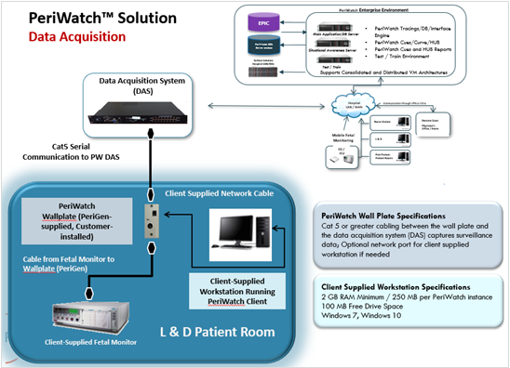
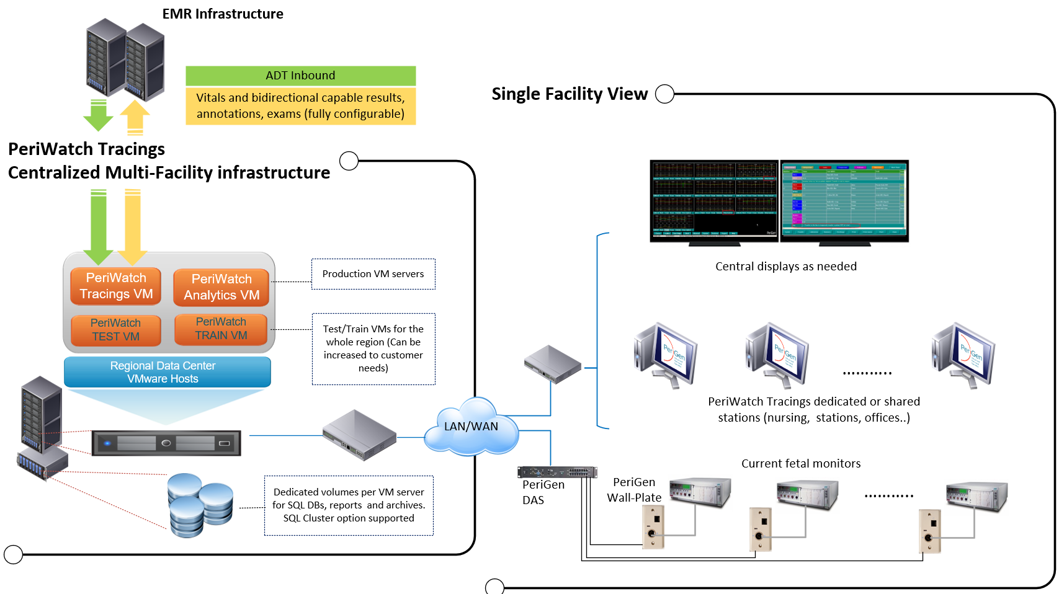

Please provide any additional comments specific to this section, if necessary:

Information Classification

Select all types of information that will be processed, stored or transmitted by the system.
Public
Business Sensitive – Employee information
Business Sensitive – Contracts or business agreements
Confidential – PHI (Protected Health Information)
Confidential – PII (Personally Identifiable Information)
Confidential – PCI (Payment Card Industry)/Credit Card information
Confidential – Account information, such as account numbers, credentials or other information used for account identification.
If information is classified in other than the above categories, please identify and explain below:

If Confidential or Business Sensitive information will be stored, processed or transmitted by the system, please provide a detailed list of information collected (i.e. patient name, DOB, address, account number, IP Address):

ADT inbound for basic patient identifiers (name, MRN, Account/visit number, Relevant OB Patient clinical data (vitals, tracings, charted OB data)

Please provide any additional comments specific to this section, if necessary:

System Requirements

Please outline the system requirements. This should include all hardware and software requirements and dependencies, as well as recommended configurations and best practices, for all system components as it relates to MIHS.
Please see attached

Please provide product white papers and installation/configuration guides as it relates to the overall implementation and use of the system.
The system is installed by PeriGen personnel according to joint design sessions with the customer. The customer only needs to provide the server VMs and SQL license/server. In addition, HL7 interfaces need to be configured between the EMR and the PeriGen system. The interface specifications are attached.

Please provide any additional comments specific to this section, if necessary:

Business Continuity and Disaster Recovery

Describe your business continuity methodologies. For example, what is your recommended best practice as to how the information is replicated or maintained, and what are the components of the redundant system?

All data is maintained in MS SQL server which can be protected with a clustered configuration and standard backup. Application services are installed on customer provided VMs leveraging VMware HA option for high availably.

Describe your disaster recovery methodologies. For example, from where, and how, do I recover the information according to your recommended best practices? If using hosted services, describe RTO/RPO objectives.
As mentioned above, the PeriWatch solution relies heavily on customer infrastructure for redundancy, backup and VM infrastructure. For full recovery from backup, RPO/RTO are directly related to the number of SQL backups and transaction shipping that can be reasonably scheduled on the customer network. These are typically discussed during pre-install activities and architected as a function of customer expectations and capabilities.

Describe how you manage data archiving. For example, what is your best practice for the recommended data retention policies, if any, and how is MIHS’s data dispositioned if the contract is terminated?
All data is stored in SQL without any deletion. The only exception are long term archives that are encrypted. In parallel, PeriGen provides an option to export report and tracing data in PDF format (ColdFeed) which allows the customer to import those into the EMR document management module. This capability provides access to key information from the EMR completely independently from the PeriGen solution (in the event of termination)

Please provide any additional comments specific to this section, if necessary:

Threat Management

Describe your best practices for system patching. For example, should MIHS follow your prescribed/approved patch list or simply follow Microsoft’s patch cycle?
We strongly encourage the customer to apply Microsoft security and hotfixes. We expect the customer to check with PeriGen support prior to applying service packs.

Please describe your process for supporting vendor security patch releases, including zero-day patches. For example, how long does it take to test and approve security patches once they are released?

We strongly encourage customer to apply patches to TEST environment first, perform basic functions followed by deployment to Production servers. PeriGen development staff is continually testing on the latest patches and hotfixes from Microsoft. In the unlikely event of a conflict, PeriGen will advise the customer of such conflict as soon as it is discovered.

Describe any antivirus requirements. Provide recommended exclusions and supporting documentation, if applicable.
See the attached AV exclusions document.

Describe the application lifecycle. For example, how often are updates and patches published for the software?
Typically, there are 2 maintenance releases a year. Hotfixes are released depending on severity/impact on patient safety.

Describe your abilities and limitations integrating with additional security controls, such as SSL/TLS, SFTP, Biometrics, SSO, and 2-factor authentication systems.
All communication between server components and clients are secured with customer supplied SSL certificates. AD authentication and SSO capabilities with major EMRs.

Describe your practices for systems security assurance, such as annual penetration testing and vulnerability scanning.
Vulnerability and penetration scanning have been traditionally performed as part of standard development and QA activities. Starting 2019, 3rd party tools and services are used to complement and enhance those product development activities.

Please provide any additional comments specific to this section, if necessary:

Data Security

Describe the encryption systems used for data at rest and in motion, including versions, key lengths, ciphers and other details. Please also indicate if you support MIHS encrypting all data in motion and at rest.
Data in motion is always encrypted using customer supplied SSL certificates while data at rest in MS SQL supports SQL TDE full database encryption.

Describe your key management practices. For example, do you use Public Key Infrastructure (PKI) or other key management methodologies? If using PKI, please name the PKI used. If other key management methodologies are used, please describe.
The PeriGen software is hosted on Windows 2012 R2 server and Windows 7 and 10 clients and relies on Microsoft PKI implementations. As such, any infrastructure/configuration supported/mandated by the customer should be compatible with the PeriGen system requirements.

Does the system send email messages?
Yes
No
If “yes”, proceed with the following questions. Otherwise, proceed to the next question.

What are the SMTP servers, or 3rd party mail systems, used (ie. MailChimp)?

What is the estimated volume of email?

MIHS does not allow their domains to be spoofed. Will the mihs.org domain be spoofed for any reason?
No

Does the system support TLS connections? If so, please provide supporting technical documentation.
Yes, TLS 1.2 and above for all service endpoints.

If using hosted services in a shared or non-dedicated environment, describe how MIHS data is isolated from other customers’ data.
NA. All servers are to be hosted at MIHS.

Please provide any additional comments specific to this section, if necessary:

Audit and Activity Logging

Does the system provide system level logging including access, failed access, account creation, modification and deletion, and system configuration changes?
Yes
No
If “Yes”, is this logging available to MIHS?
Yes

If PHI is processed, stored or transferred, will logging be conducting in accordance with HIPAA regulations?
Yes
No
If “No”, please explain.

Can the logs collected be forwarded to a SIEM or central logging system?
Yes
No

Please provide any additional comments specific to this section, if necessary:
The logs mentioned in point 7.3 are stored in a specific SQL tables which are not natively ready for forwarding to external systems.

Access Controls

Describe the configuration of user access.
The system relies on AD authentication and authorization where user groups setup in the PeriGen system match AD user groups. Upon user authentication, if the user belongs to a given group, the system assigns the respective group authorization as configured by the system administrator.

Does the system use local accounts or groups? If so, please describe.
As part of system installations, several application groups are created in collaboration with the customer. As mentioned above, those need to map to identical security groups in AD. Users part of these groups are allowed the appropriate access.

Does the system use Active Directory/LDAP for authentication and/or authorization? If so, please describe.
Yes as explained above.

Does the system use a hybrid authorization/authentication approach? If so, please describe.
No except for built-in administrator accounts used for PeriGen technical support.

Will all system users, including Administrators have unique accounts?
Yes
No
Please explain or provide additional comments:
All users have unique accounts except for a built-in administrative user used by PeriGen for support activities.

Does the system support RBAC, or Role Based Access Control, in which users are setup in groups with specific access?
Yes
No
If “No”, please explain:

Does the system support an 8-character complex password policy?
Yes
No
Please explain or provide additional comments:
Controlled by AD administrator.

Does the system automatically logout users after a specified period of inactivity?
Yes
No
Please explain or provide additional comments:
This is configurable to customer policies.

Are system user accounts locked after a specified number of failed login attempts?
Yes
No
Please explain or provide additional comments:
Again, this is configurable by AD administrators

Does your system have the ability to integrate with an Identity Management system? If so, please describe interface services that might be available for integration.
Yes
No
Please explain or provide additional comments:

List all Service Accounts that will be utilized by the system.
Question unclear?

Will the system be accessed by users (end users, support, vendors) remotely?
Yes
No
If “Yes”, describe the use cases for remote access, such as vendors for remote support or employees for data processing.
Only PeriGen Operations/Support staff have access to customer system via SecureLink (a secure service that needs to be configured and approved by the customer). Access is only performed for support, maintenance or installation activities.

Does your system support 2-factor authentication?
Yes
No
Please explain or provide additional comments:
SecureLink service relies on 2 factor authentication.

Please provide any additional comments specific to this section, if necessary:

Other

Please provide any other comments or information regarding this assessment:

